**METCA & NYSME Train Show**

**Saturday, April 12, 2025**

**St. Joseph’s School**

**120 Hoboken Rd., East Rutherford, NJ 07073**

**Less than 1 mile from MetLife Stadium**

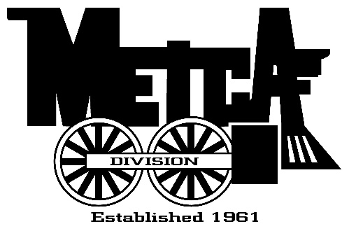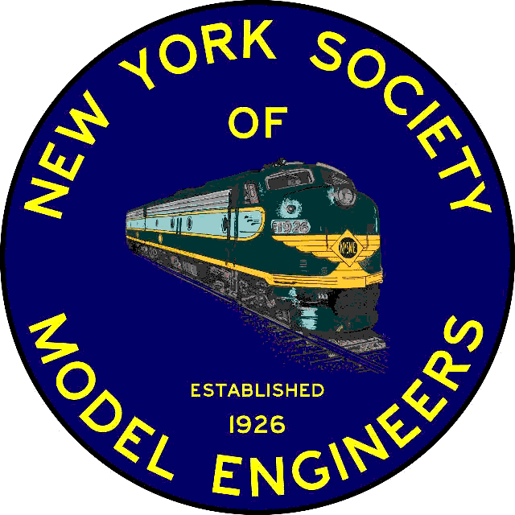

**Coupled up**

**for a Great**

**New Jersey**

**Show**

METCA/TCA/NYSME members admitted at 8 AM ~ Public at 9 AM ~ Show Runs until 2 PM

**New Vendors! Door prizes! New Friends! Great trains!**

**Entrance to School and spacious parking lot off of Hoboken Rd. (Road signs will be posted)**

**Easy access from Rt. 17 north & south**

**Added attraction: NYSME Club layouts will be open (at 12 noon) FREE to attendees.**

---------------------------------------------------------------------------------------------------------------------------------------------------------------

** Please reserve ___ tables at the Show @ $25.00. Each paid table includes 1 admission. $ ______**

**Children younger than 16 and wives are admitted free.**

** Yes! I want to GET a 4th Table for FREE!! Pay for 3 tables and the 4th one is FREE.**

**Total of Check or Money Order: $ ______**

**NOTE: RESERVED TABLES MUST BE PAID FOR TWO WEEKS PRIOR TO SHOW**

Waiting list will be filled from unpaid tables. Contact NYSME Office 201-939-9212 for availability.

E-Mail - [contact@modelengineers.org](mailto:contact@modelengineers.org) Table reservations will be confirmed once received.

Set up begins at 7:00 AM. “Reserved tables" held until 9:00 AM.

Make registration checks payable to: NYSME

Mail to: NYSME, 341 Hoboken Road, Carlstadt, NJ 07072

**Name: ________________________________________________ Phone: (_______) ____________________**

**Address: ____________________________City: _________________State: _____ Zip+4: ________-______**

**Email Address____________________________________________________TCA#____________________**

**Standards Statement: By applying for tables, I agree to comply with all of the rules and regulations of the Train Collector’s Association (TCA).**

**Spring Show, To Be Announced**

**check** [**www.METCA.org**](http://www.METCA.org) **for more info**